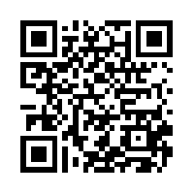
Remind: Safe Classroom Communication

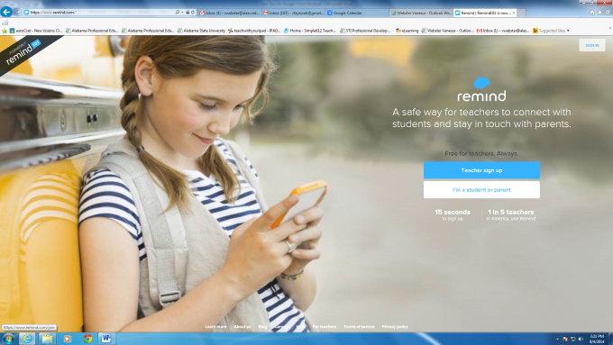
Google Search Remind (Click on first link) and create an account

Invite Students to join your class
Home Button
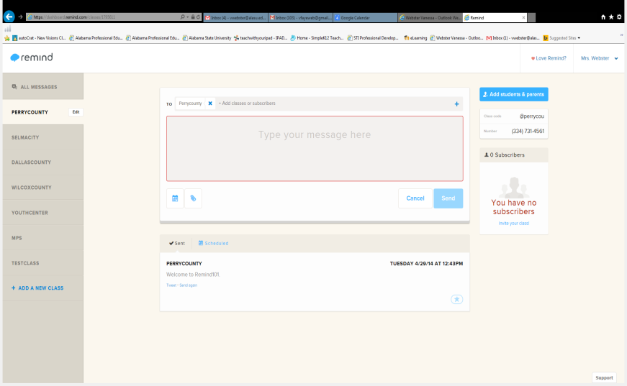
Invite joiners:
- Class Instructions
- Email the link
- Via SMS
- PDF (Handout)
Add Classes
Benefits:
One-way broadcast messaging
No exchange of personal information
Logged Communication History
Send message in real time
Schedule a message to send out
Add an attachment
Edit Message
Create Hyperlink
Server Security (every click, page view, and text message is hosted on a cloud platform).

